Documentation for VIHierarchy
VIHierarchy can do the following operations on your LabVIEW project: list the VIs, create HTML documentation, copy or cleanup directories and libraries, and clone the entire project. The front panel is shown in figure 1.
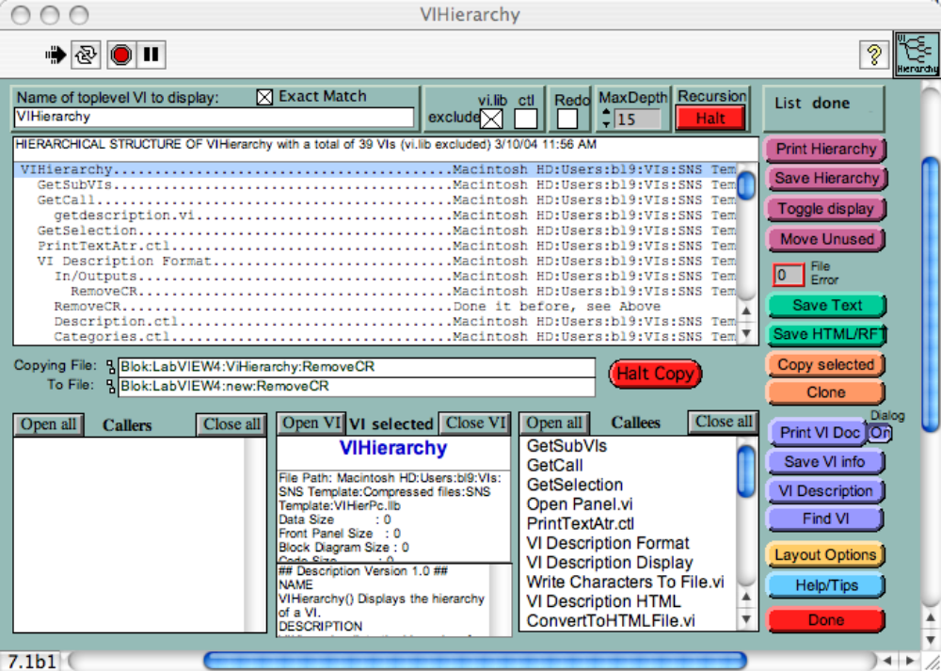
Figure 1. Front Panel of VIHierarchy.

Traversing the Hierarchy
You can traverse the hierarchy of VIs by clicking in the list on the top. The three displays at the bottom will update. The middle bottom display shows information about the currently selected VI, the left display shows the VIs that call the selected VI, while the right display shows the subVIs of the selected VI. When you click on a VI name in the left or right bottom display, that VI will become the selected VI. The top display will scroll to the selected VI.

Listing VIs
The list can be shown as an indented list of VI names or an alphabetized list of the paths, The indented hierarchy list gives a good overview of the project while the alphabetical path list shows you where the VIs are located, see figure 2. Use the help window to view instructions for each display element. Clicking on a VI from the hierarchy list on the top of the panel will display information about that VI in the middle bottom display (VI selected). The VI Description option retrieves information from the getinfo field of a VI. If this is formatted properly (see VI Description Format) then you'll get to see a nice overview of the VI's function, in/outputs, etc. The left bottom display lists the callers, the right bottom display lists the callees. Selecting any VI in the callers or callees list will make that VI the VI selected. This way you can go up or down in the VI hierarchy. By manually typing in a partial VI name and selecting the Find VI button you can find the VI. Buttons above the Callers/Selected VI/Callees list allow opening or closing the listed VIs.

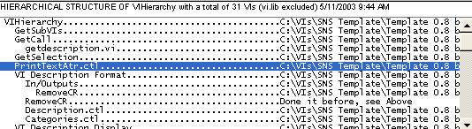
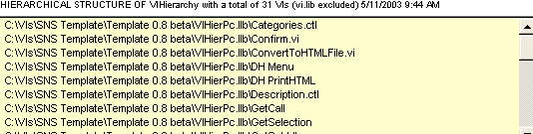
Figure 2. Listing by hierarchy or pathname.

Documenting your project
The hierarchy can be saved as an HTML or RFT document set. The HTML document for a VI includes links to callers and callees that are clickable and move you around in the hierarchy. You can use he “Layout Options” button to select between standard, panel, subVI, and complete documentation formats. Figure 3 shows the created HTML documentation of the utility itself.

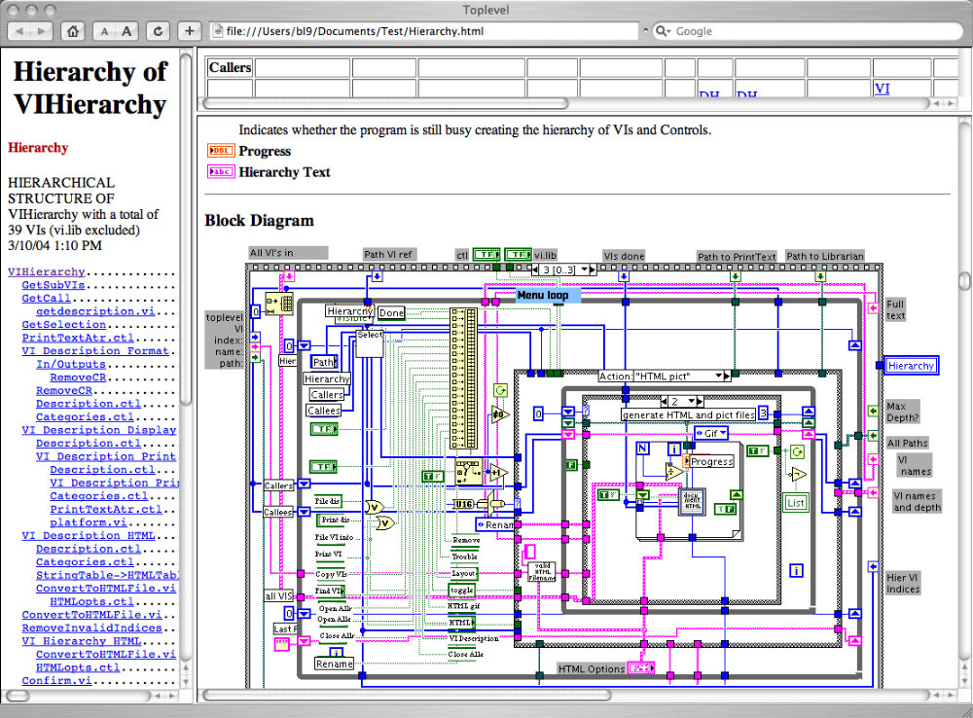
Figure 3. Browser view of generated HTML documentation.

Compatibility
VIHierarchy still contains the code used in LabVIEW 4 when LabVIEW didn’t have print to HTML capability. Below are the instructions for creating documentation with third party helper applications.
The print function has a special direct print option for Macintosh only that uses a CIN to allow extra options (default is PowerPC, load CIN PrintText.lsb for 68k). VIs with vi.lib in their path or with .ctl in their name can be excluded (use the checkboxes) from the hierarchy listing but not from the callers and callees lists below. Note that alignment of text is dependent on using a fixed point font, make sure you have one installed and if the printout doesn't look good try another fixed point font or change its size.

Managing your VIs
You can decide to remove all VIs from a library or directory that are not part of the current hierarchy. Clicking the “Move unused” button, pops up dialog box, see figure 4. This dialog box will help you pick the VIs to remove from your current directories. You can also copy VIs to other locations with the “Copy selected” button. By shift clicking the top hierarchy list, you can select VI for copying, select the VIs then push the “Copy selected” button. A dialog will ask for the destination. You can have only one destination per selection
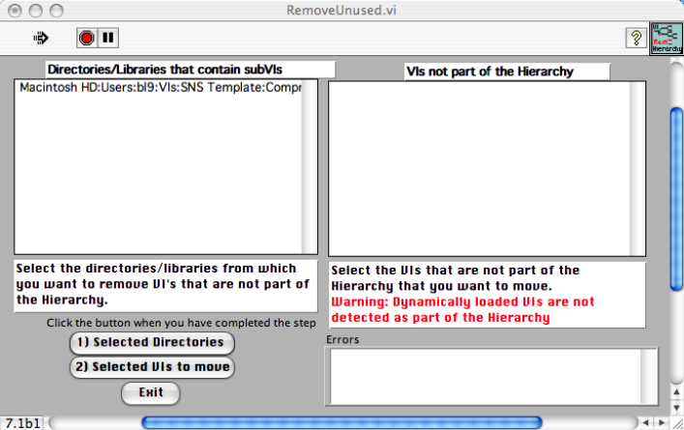
Figure 4. The “Move Unused” dialog box.

Other features folder/library that contains VIs from the hierarchy), copying of VIs, editing VI descriptions, showing VI's ordered by path, and searching for a VI name in the hierarchy. See Help/Tips button and LabVIEW Simple Help window when hovering over a button for more help.

Cloning a project
If you have a project that is very similar to a new one you are going to create, use the “Clone” feature. It can copy and rename all the VIs in your project. It decouples your new project from your old one. The clone function can add or replace a prefix (text followed by an underscore) for all VIs. You can exclude VIs from being renamed based on text in its path, see figure 5. after having selected your renaming scheme, you’re are presented with a list of all the renamed VIs and not to be renamed VIs to confirm your setup or to refine your setup. The “Clone” function is most effective if you use a naming scheme like ProjectName_Group_Routine.vi. Projectname is the same for each VI in your project, e.g. BCM. Group would reflect to what group, e.g. Acq (acquisition) or Ana (analysis), the VIs belongs, and Routine, the name of the routine, e.g. Fit. Such a name BCM_Ana_Fit.vi makes it easy to rename and easy to know in what part of the hierarchy a VI belongs. You can use the group name also for what library or what directory the VI is located.

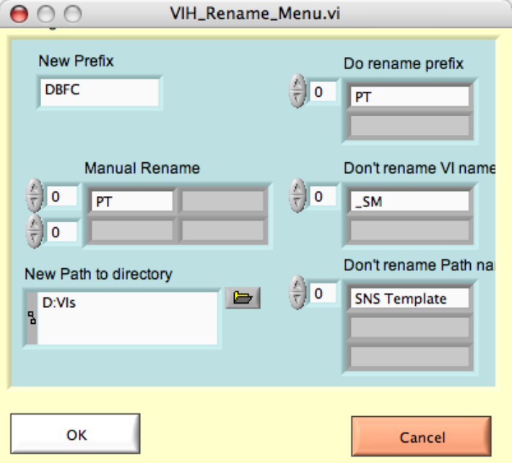
Figure 5. The rename dialog for the Clone function.

